**Part A: Password Program**

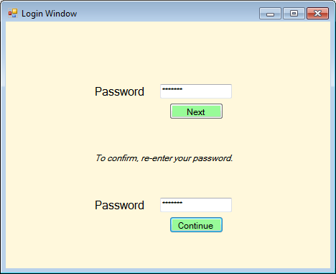

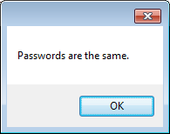

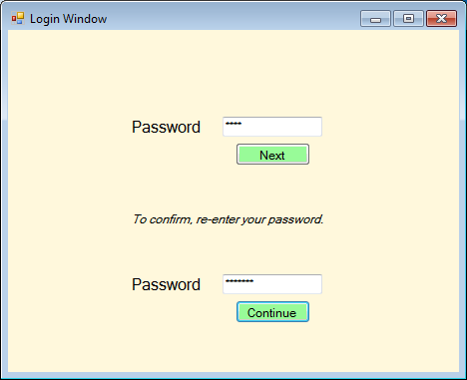

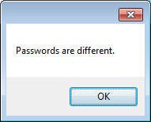

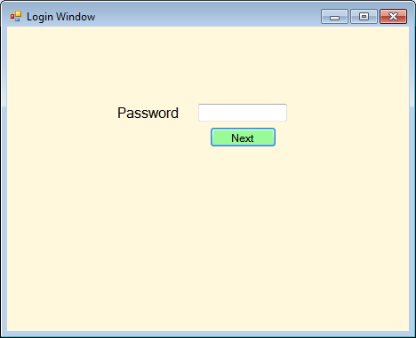

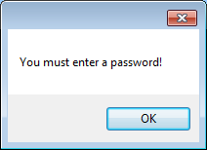

// ---------------------------------------------------------------

// Programming Assignment: LAB6A

// Developer: Anthony Meunier

// Date Written: 8/16/2014

// Purpose: Password Program

// ---------------------------------------------------------------

using System;

using System.Collections.Generic;

using System.ComponentModel;

using System.Data;

using System.Drawing;

using System.Linq;

using System.Text;

using System.Threading.Tasks;

using System.Windows.Forms;

namespace CIS170B_Lab6A_Meunier_A

{

public partial class Form1 : Form

{

public Form1()

{

InitializeComponent();

}

private void textBox2_TextChanged(object sender, EventArgs e)

{

}

//next button function

private void btnNext_Click(object sender, EventArgs e)

{

//declare variables

string password1, password2;

password1 = (txtPassword1.Text);

password2 = (txtPassword2.Text);

//verify first password textbox is not blank

if (!String.IsNullOrEmpty(txtPassword1.Text))

{

//make visible second password textbox etc

lblPassword2.Visible = true;

txtPassword2.Visible = true;

btnContinue.Visible = true;

lblConfirm.Visible = true;

}

//display error if textbox is empty

else

{

MessageBox.Show("You must enter a password!");

}

}

//continue button function

private void btnContinue_Click(object sender, EventArgs e)

{

//declare variables

string password1, password2;

password1 = (txtPassword1.Text);

password2 = (txtPassword2.Text);

//verify first password textbox is not blank

if (!String.IsNullOrEmpty(txtPassword1.Text))

//check if first password textbox equals second password textbox

if (password1 == password2)

{

MessageBox.Show("Passwords are the same.");

}

//check if passwords do not equal each other

else

{

MessageBox.Show("Passwords are different.");

}

//display error if textbox is empty

else

{

MessageBox.Show("You must enter a password!");

}

}

private void label1_Click(object sender, EventArgs e)

{

}

private void txtPassword1_TextChanged(object sender, EventArgs e)

{

}

}

}

**Part B: Number Guessing Game**

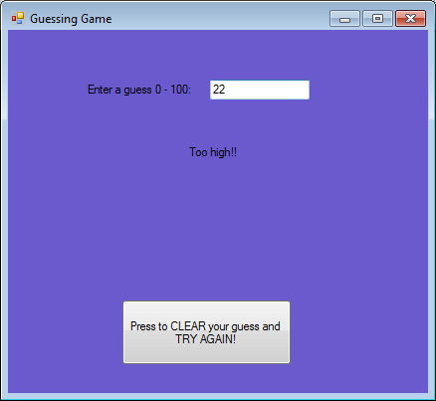

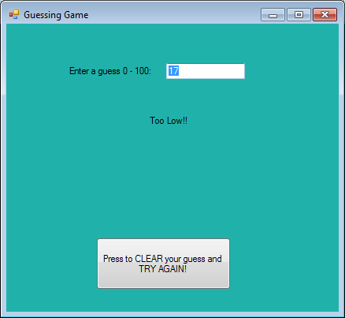

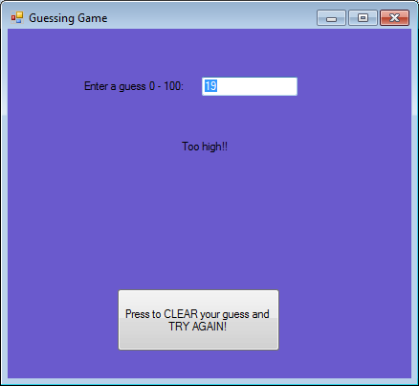

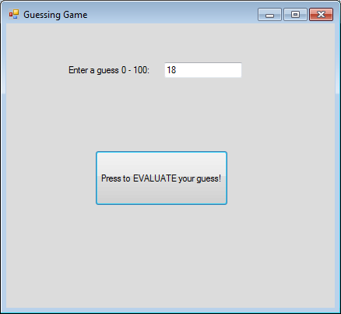

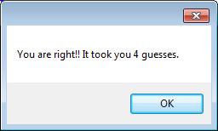

// ---------------------------------------------------------------

// Programming Assignment: LAB6B

// Developer: Anthony Meunier

// Date Written: 8/17/2014

// Purpose: Number Guessing Game

// ---------------------------------------------------------------

using System;

using System.Collections.Generic;

using System.ComponentModel;

using System.Data;

using System.Drawing;

using System.Linq;

using System.Text;

using System.Threading.Tasks;

using System.Windows.Forms;

namespace CIS170B_Lab6B_Meunier_A

{

public partial class Form1 : Form

{

//declare and initialize global variables

Random r = new Random();

int target;

int numGuesses = 0;

public Form1()

{

//randomly pick a target number between 0 and 100

InitializeComponent();

target = r.Next(0, 100);

}

private void Form1_Load(object sender, EventArgs e)

{

}

//evaluate button click function

private void btnEval_Click(object sender, EventArgs e)

{

int num1;

//check to make sure textbox is not empty

if (!String.IsNullOrEmpty(txtNumberEntered.Text))

{

//counter for number of guesses

numGuesses++;

//pull guess from the textbox

num1 = Convert.ToInt32(txtNumberEntered.Text);

//if guess is less than random computer target

if (num1 < target)

{

//make evaluate button invisible

btnEval.Visible = false;

//change the label message

lblMessage.Text = "Too Low!!";

//make the label message visible

lblMessage.Visible = true;

//change background color

this.BackColor = Color.LightSeaGreen;

//make try again button visible

btnTryAgain.Visible = true;

}

//if guess is greater than random computer target

else if (num1 > target)

{

//make the evaluate button invisible

btnEval.Visible = false;

//change the label message

lblMessage.Text = "Too high!!";

//make the label message visible

lblMessage.Visible = true;

//change the background color

this.BackColor = Color.SlateBlue;

//make the try again button visible

btnTryAgain.Visible = true;

}

//display message indicating user guessed correctly and display the number of guesses it took

else

MessageBox.Show("You are right!! It took you " + numGuesses + " guesses.");

}

}

//try again button click function

private void btnTryAgain_Click(object sender, EventArgs e)

{

//change the background color to original since we are trying guess again

this.BackColor = Color.Gainsboro;

//make the try again button invisible

btnTryAgain.Visible = false;

//clear the guess textbox

txtNumberEntered.Clear();

//make the label message invisible

lblMessage.Visible = false;

//make the evaluate button visible

btnEval.Visible = true;

}

}

}